Sharepoint 2013 AgeasNet Configuration

Spazsp2013-01

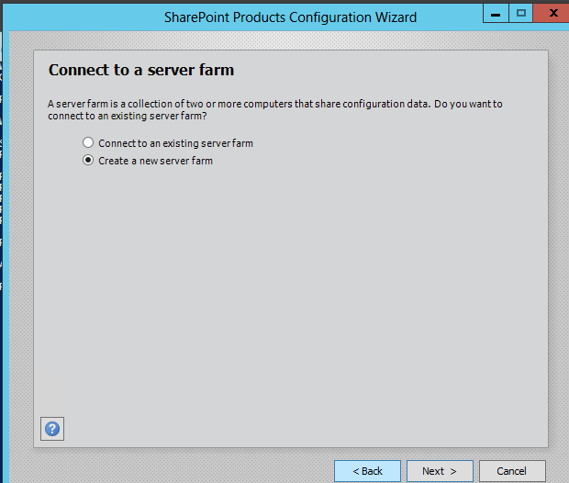

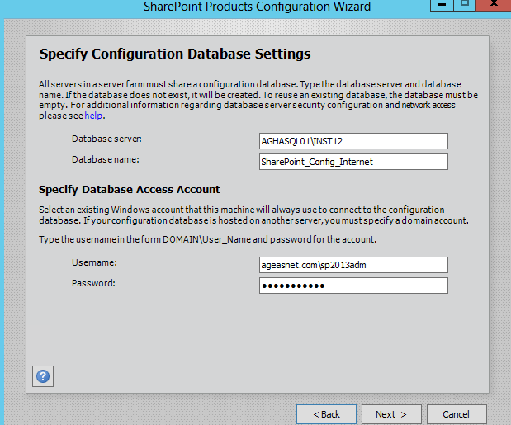

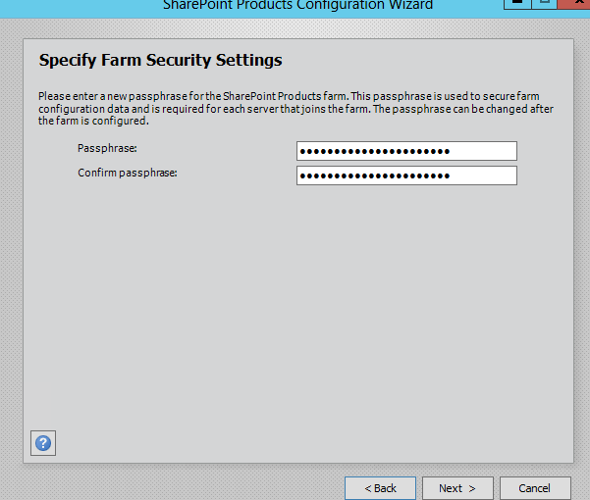

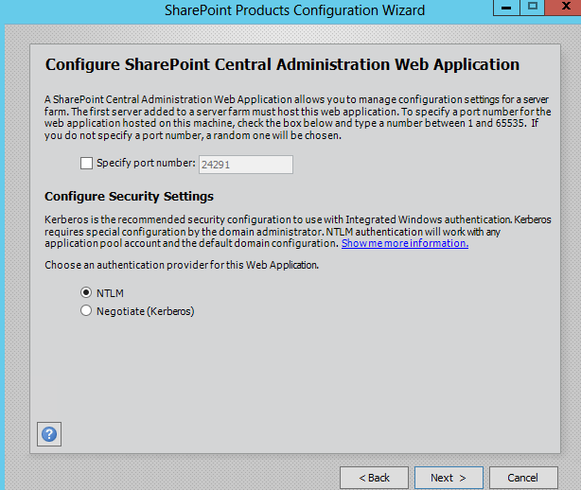

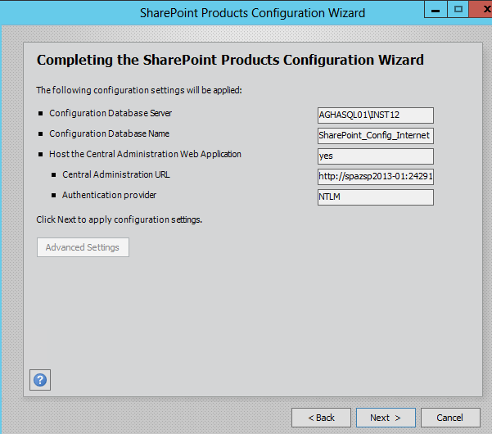

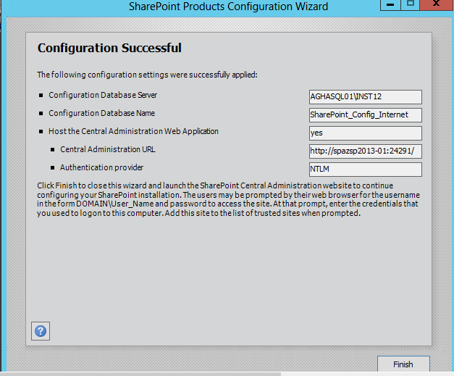

@ CA

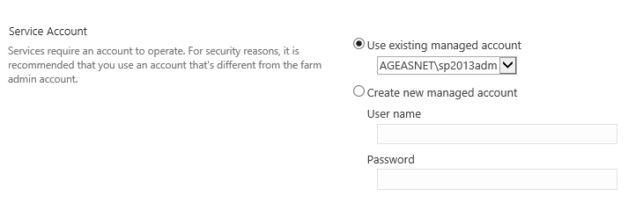

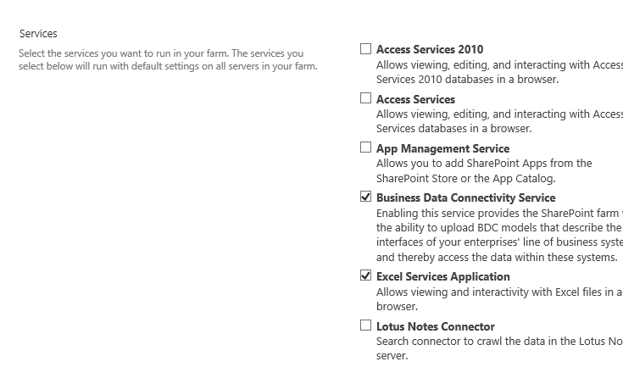

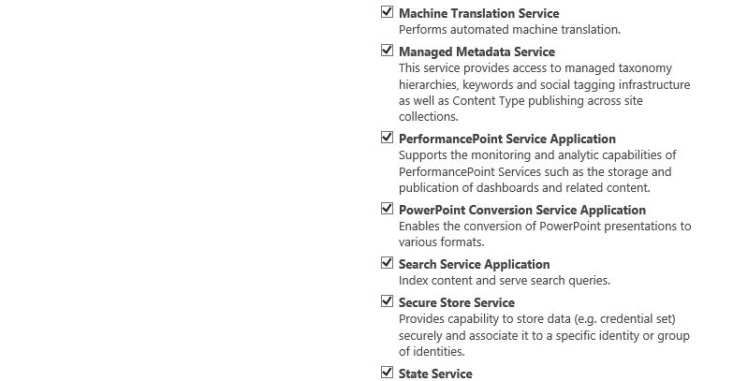

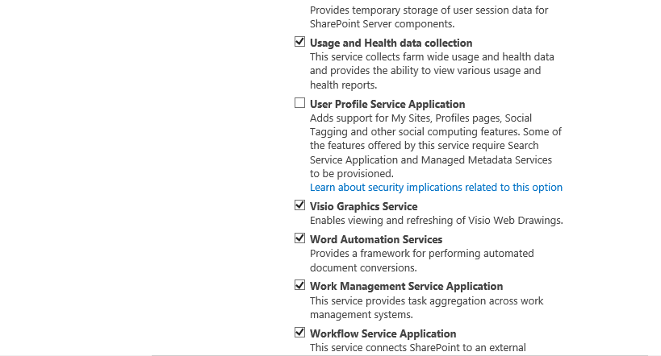

SPAZSP2013-02

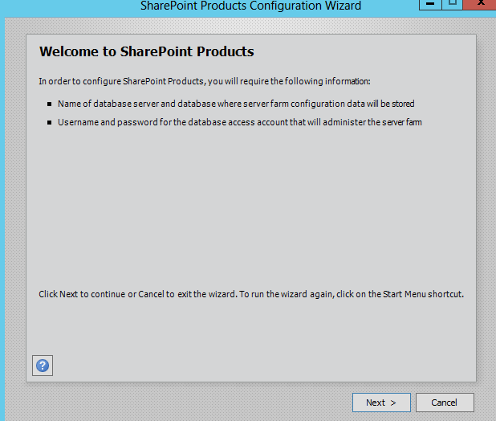

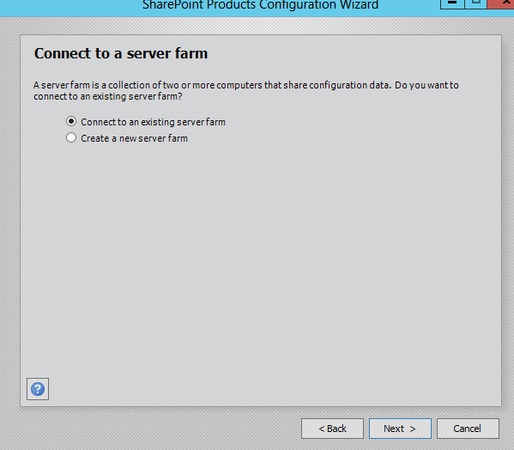

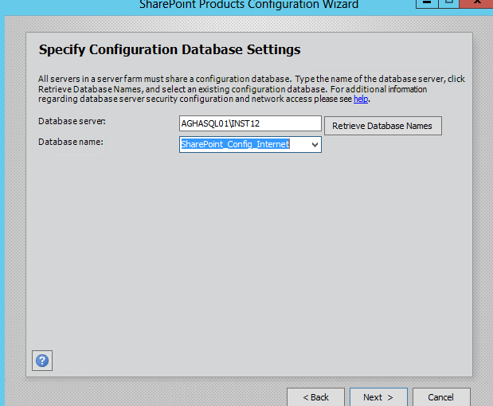

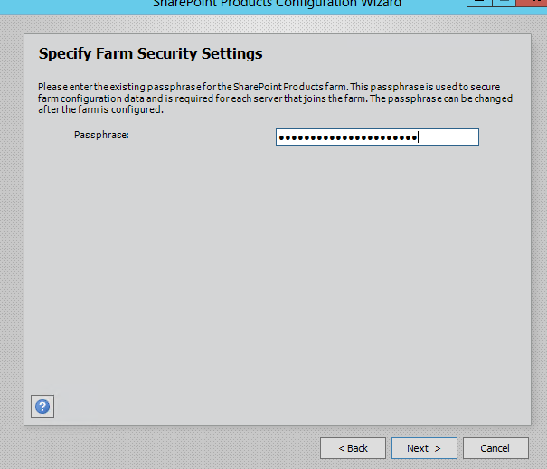

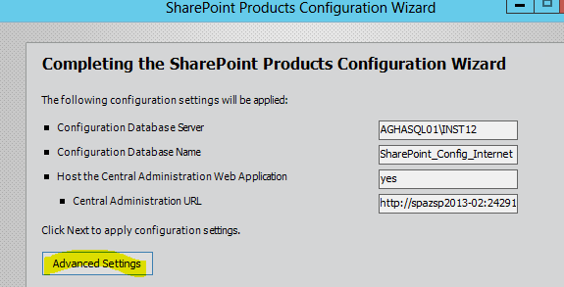

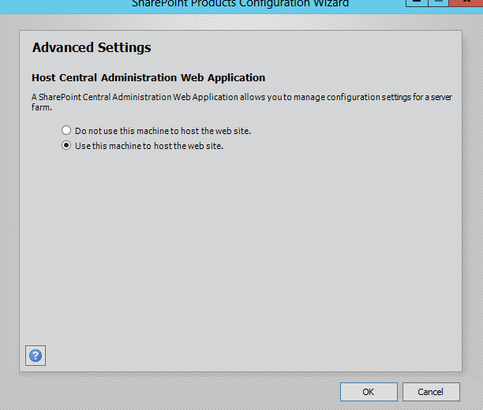

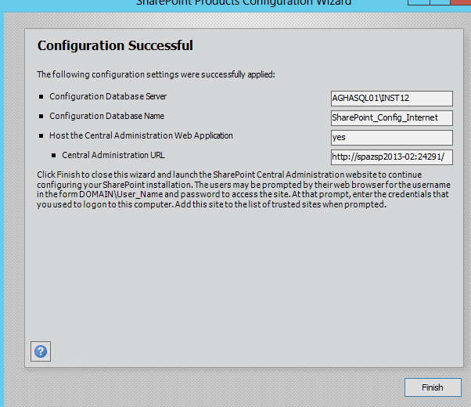

Add BD’s to SQL HA

Prerequesitos: Full backup , Recovery Model FULL

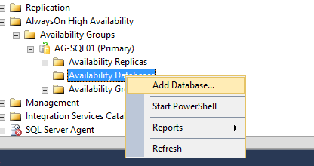

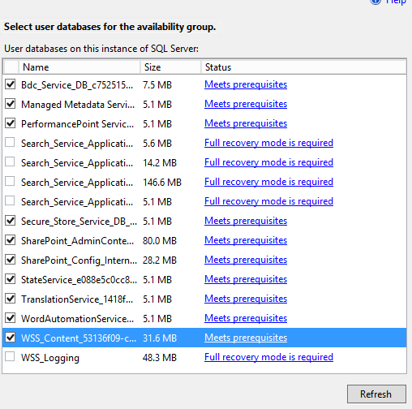

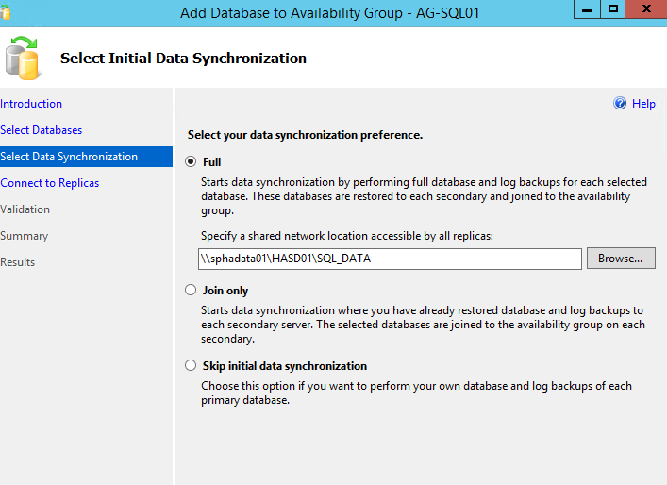

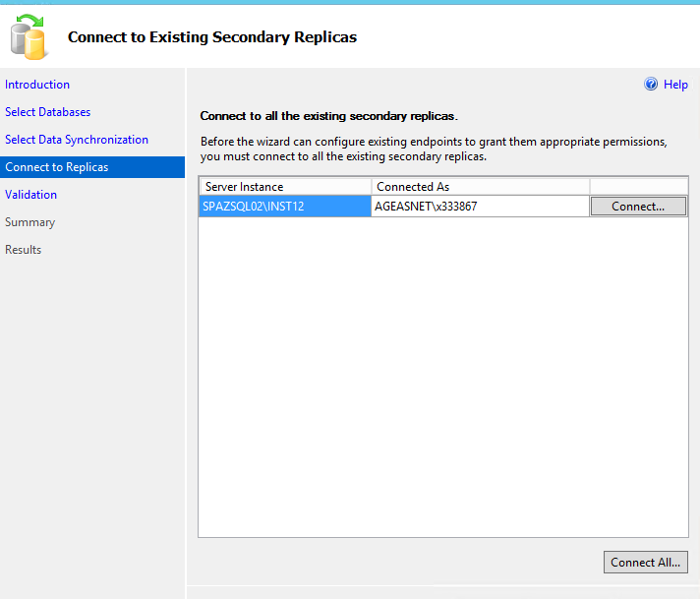

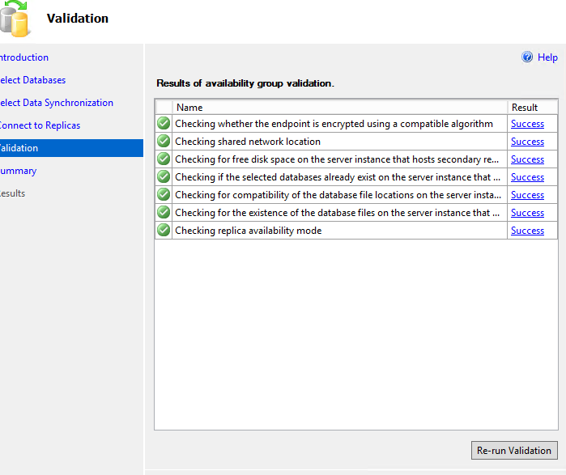

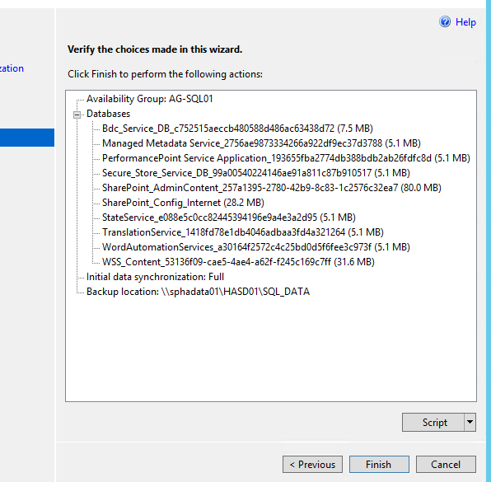

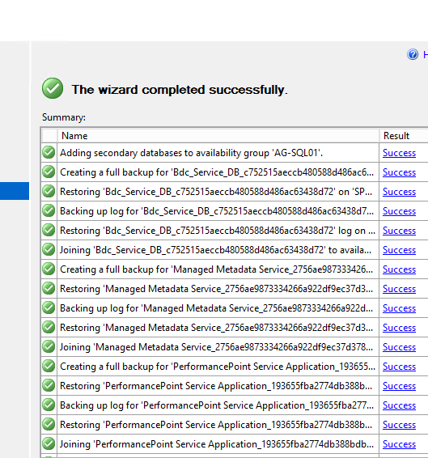

SQL Script:

--- YOU MUST EXECUTE THE FOLLOWING SCRIPT IN SQLCMD MODE.

:Connect AGHASQL01\INST12

USE [master]

GO

ALTER AVAILABILITY GROUP [AG-SQL01]

ADD DATABASE [Bdc_Service_DB_c752515aeccb480588d486ac63438d72];

GO

USE [master]

GO

ALTER AVAILABILITY GROUP [AG-SQL01]

ADD DATABASE [Managed Metadata Service_2756ae9873334266a922df9ec37d3788];

GO

USE [master]

GO

ALTER AVAILABILITY GROUP [AG-SQL01]

ADD DATABASE [PerformancePoint Service Application_193655fba2774db388bdb2ab26fdfc8d];

GO

USE [master]

GO

ALTER AVAILABILITY GROUP [AG-SQL01]

ADD DATABASE [Secure_Store_Service_DB_99a00540224146ae91a811c87b910517];

GO

USE [master]

GO

ALTER AVAILABILITY GROUP [AG-SQL01]

ADD DATABASE [SharePoint_AdminContent_257a1395-2780-42b9-8c83-1c2576c32ea7];

GO

USE [master]

GO

ALTER AVAILABILITY GROUP [AG-SQL01]

ADD DATABASE [SharePoint_Config_Internet];

GO

USE [master]

GO

ALTER AVAILABILITY GROUP [AG-SQL01]

ADD DATABASE [StateService_e088e5c0cc82445394196e9a4e3a2d95];

GO

USE [master]

GO

ALTER AVAILABILITY GROUP [AG-SQL01]

ADD DATABASE [TranslationService_1418fd78e1db4046adbaa3fd4a321264];

GO

USE [master]

GO

ALTER AVAILABILITY GROUP [AG-SQL01]

ADD DATABASE [WordAutomationServices_a30164f2572c4c25bd0d5f6fee3c973f];

GO

USE [master]

GO

ALTER AVAILABILITY GROUP [AG-SQL01]

ADD DATABASE [WSS_Content_53136f09-cae5-4ae4-a62f-f245c169c7ff];

GO

:Connect AGHASQL01\INST12

BACKUP DATABASE [Bdc_Service_DB_c752515aeccb480588d486ac63438d72] TO DISK = N'\\sphadata01\HASD01\SQL_DATA\Bdc_Service_DB_c752515aeccb480588d486ac63438d72.bak' WITH COPY_ONLY, FORMAT, INIT, SKIP, REWIND, NOUNLOAD, COMPRESSION, STATS = 5

GO

:Connect SPAZSQL02\INST12

RESTORE DATABASE [Bdc_Service_DB_c752515aeccb480588d486ac63438d72] FROM DISK = N'\\sphadata01\HASD01\SQL_DATA\Bdc_Service_DB_c752515aeccb480588d486ac63438d72.bak' WITH NORECOVERY, NOUNLOAD, STATS = 5

GO

:Connect AGHASQL01\INST12

BACKUP LOG [Bdc_Service_DB_c752515aeccb480588d486ac63438d72] TO DISK = N'\\sphadata01\HASD01\SQL_DATA\Bdc_Service_DB_c752515aeccb480588d486ac63438d72_20140930193751.trn' WITH NOFORMAT, NOINIT, NOSKIP, REWIND, NOUNLOAD, COMPRESSION, STATS = 5

GO

:Connect SPAZSQL02\INST12

RESTORE LOG [Bdc_Service_DB_c752515aeccb480588d486ac63438d72] FROM DISK = N'\\sphadata01\HASD01\SQL_DATA\Bdc_Service_DB_c752515aeccb480588d486ac63438d72_20140930193751.trn' WITH NORECOVERY, NOUNLOAD, STATS = 5

GO

:Connect SPAZSQL02\INST12

-- Wait for the replica to start communicating

begin try

declare @conn bit

declare @count int

declare @replica_id uniqueidentifier

declare @group_id uniqueidentifier

set @conn = 0

set @count = 30 -- wait for 5 minutes

if (serverproperty('IsHadrEnabled') = 1)

and (isnull((select member_state from master.sys.dm_hadr_cluster_members where upper(member_name COLLATE Latin1_General_CI_AS) = upper(cast(serverproperty('ComputerNamePhysicalNetBIOS') as nvarchar(256)) COLLATE Latin1_General_CI_AS)), 0) <> 0)

and (isnull((select state from master.sys.database_mirroring_endpoints), 1) = 0)

begin

select @group_id = ags.group_id from master.sys.availability_groups as ags where name = N'AG-SQL01'

select @replica_id = replicas.replica_id from master.sys.availability_replicas as replicas where upper(replicas.replica_server_name COLLATE Latin1_General_CI_AS) = upper(@@SERVERNAME COLLATE Latin1_General_CI_AS) and group_id = @group_id

while @conn <> 1 and @count > 0

begin

set @conn = isnull((select connected_state from master.sys.dm_hadr_availability_replica_states as states where states.replica_id = @replica_id), 1)

if @conn = 1

begin

-- exit loop when the replica is connected, or if the query cannot find the replica status

break

end

waitfor delay '00:00:10'

set @count = @count - 1

end

end

end try

begin catch

-- If the wait loop fails, do not stop execution of the alter database statement

end catch

ALTER DATABASE [Bdc_Service_DB_c752515aeccb480588d486ac63438d72] SET HADR AVAILABILITY GROUP = [AG-SQL01];

GO

:Connect AGHASQL01\INST12

BACKUP DATABASE [Managed Metadata Service_2756ae9873334266a922df9ec37d3788] TO DISK = N'\\sphadata01\HASD01\SQL_DATA\Managed Metadata Service_2756ae9873334266a922df9ec37d3788.bak' WITH COPY_ONLY, FORMAT, INIT, SKIP, REWIND, NOUNLOAD, COMPRESSION, STATS = 5

GO

:Connect SPAZSQL02\INST12

RESTORE DATABASE [Managed Metadata Service_2756ae9873334266a922df9ec37d3788] FROM DISK = N'\\sphadata01\HASD01\SQL_DATA\Managed Metadata Service_2756ae9873334266a922df9ec37d3788.bak' WITH NORECOVERY, NOUNLOAD, STATS = 5

GO

:Connect AGHASQL01\INST12

BACKUP LOG [Managed Metadata Service_2756ae9873334266a922df9ec37d3788] TO DISK = N'\\sphadata01\HASD01\SQL_DATA\Managed Metadata Service_2756ae9873334266a922df9ec37d3788_20140930193751.trn' WITH NOFORMAT, NOINIT, NOSKIP, REWIND, NOUNLOAD, COMPRESSION, STATS = 5

GO

:Connect SPAZSQL02\INST12

RESTORE LOG [Managed Metadata Service_2756ae9873334266a922df9ec37d3788] FROM DISK = N'\\sphadata01\HASD01\SQL_DATA\Managed Metadata Service_2756ae9873334266a922df9ec37d3788_20140930193751.trn' WITH NORECOVERY, NOUNLOAD, STATS = 5

GO

:Connect SPAZSQL02\INST12

-- Wait for the replica to start communicating

begin try

declare @conn bit

declare @count int

declare @replica_id uniqueidentifier

declare @group_id uniqueidentifier

set @conn = 0

set @count = 30 -- wait for 5 minutes

if (serverproperty('IsHadrEnabled') = 1)

and (isnull((select member_state from master.sys.dm_hadr_cluster_members where upper(member_name COLLATE Latin1_General_CI_AS) = upper(cast(serverproperty('ComputerNamePhysicalNetBIOS') as nvarchar(256)) COLLATE Latin1_General_CI_AS)), 0) <> 0)

and (isnull((select state from master.sys.database_mirroring_endpoints), 1) = 0)

begin

select @group_id = ags.group_id from master.sys.availability_groups as ags where name = N'AG-SQL01'

select @replica_id = replicas.replica_id from master.sys.availability_replicas as replicas where upper(replicas.replica_server_name COLLATE Latin1_General_CI_AS) = upper(@@SERVERNAME COLLATE Latin1_General_CI_AS) and group_id = @group_id

while @conn <> 1 and @count > 0

begin

set @conn = isnull((select connected_state from master.sys.dm_hadr_availability_replica_states as states where states.replica_id = @replica_id), 1)

if @conn = 1

begin

-- exit loop when the replica is connected, or if the query cannot find the replica status

break

end

waitfor delay '00:00:10'

set @count = @count - 1

end

end

end try

begin catch

-- If the wait loop fails, do not stop execution of the alter database statement

end catch

ALTER DATABASE [Managed Metadata Service_2756ae9873334266a922df9ec37d3788] SET HADR AVAILABILITY GROUP = [AG-SQL01];

GO

:Connect AGHASQL01\INST12

BACKUP DATABASE [PerformancePoint Service Application_193655fba2774db388bdb2ab26fdfc8d] TO DISK = N'\\sphadata01\HASD01\SQL_DATA\PerformancePoint Service Application_193655fba2774db388bdb2ab26fdfc8d.bak' WITH COPY_ONLY, FORMAT, INIT, SKIP, REWIND, NOUNLOAD, COMPRESSION, STATS = 5

GO

:Connect SPAZSQL02\INST12

RESTORE DATABASE [PerformancePoint Service Application_193655fba2774db388bdb2ab26fdfc8d] FROM DISK = N'\\sphadata01\HASD01\SQL_DATA\PerformancePoint Service Application_193655fba2774db388bdb2ab26fdfc8d.bak' WITH NORECOVERY, NOUNLOAD, STATS = 5

GO

:Connect AGHASQL01\INST12

BACKUP LOG [PerformancePoint Service Application_193655fba2774db388bdb2ab26fdfc8d] TO DISK = N'\\sphadata01\HASD01\SQL_DATA\PerformancePoint Service Application_193655fba2774db388bdb2ab26fdfc8d_20140930193751.trn' WITH NOFORMAT, NOINIT, NOSKIP, REWIND, NOUNLOAD, COMPRESSION, STATS = 5

GO

:Connect SPAZSQL02\INST12

RESTORE LOG [PerformancePoint Service Application_193655fba2774db388bdb2ab26fdfc8d] FROM DISK = N'\\sphadata01\HASD01\SQL_DATA\PerformancePoint Service Application_193655fba2774db388bdb2ab26fdfc8d_20140930193751.trn' WITH NORECOVERY, NOUNLOAD, STATS = 5

GO

:Connect SPAZSQL02\INST12

-- Wait for the replica to start communicating

begin try

declare @conn bit

declare @count int

declare @replica_id uniqueidentifier

declare @group_id uniqueidentifier

set @conn = 0

set @count = 30 -- wait for 5 minutes

if (serverproperty('IsHadrEnabled') = 1)

and (isnull((select member_state from master.sys.dm_hadr_cluster_members where upper(member_name COLLATE Latin1_General_CI_AS) = upper(cast(serverproperty('ComputerNamePhysicalNetBIOS') as nvarchar(256)) COLLATE Latin1_General_CI_AS)), 0) <> 0)

and (isnull((select state from master.sys.database_mirroring_endpoints), 1) = 0)

begin

select @group_id = ags.group_id from master.sys.availability_groups as ags where name = N'AG-SQL01'

select @replica_id = replicas.replica_id from master.sys.availability_replicas as replicas where upper(replicas.replica_server_name COLLATE Latin1_General_CI_AS) = upper(@@SERVERNAME COLLATE Latin1_General_CI_AS) and group_id = @group_id

while @conn <> 1 and @count > 0

begin

set @conn = isnull((select connected_state from master.sys.dm_hadr_availability_replica_states as states where states.replica_id = @replica_id), 1)

if @conn = 1

begin

-- exit loop when the replica is connected, or if the query cannot find the replica status

break

end

waitfor delay '00:00:10'

set @count = @count - 1

end

end

end try

begin catch

-- If the wait loop fails, do not stop execution of the alter database statement

end catch

ALTER DATABASE [PerformancePoint Service Application_193655fba2774db388bdb2ab26fdfc8d] SET HADR AVAILABILITY GROUP = [AG-SQL01];

GO

:Connect AGHASQL01\INST12

BACKUP DATABASE [Secure_Store_Service_DB_99a00540224146ae91a811c87b910517] TO DISK = N'\\sphadata01\HASD01\SQL_DATA\Secure_Store_Service_DB_99a00540224146ae91a811c87b910517.bak' WITH COPY_ONLY, FORMAT, INIT, SKIP, REWIND, NOUNLOAD, COMPRESSION, STATS = 5

GO

:Connect SPAZSQL02\INST12

RESTORE DATABASE [Secure_Store_Service_DB_99a00540224146ae91a811c87b910517] FROM DISK = N'\\sphadata01\HASD01\SQL_DATA\Secure_Store_Service_DB_99a00540224146ae91a811c87b910517.bak' WITH NORECOVERY, NOUNLOAD, STATS = 5

GO

:Connect AGHASQL01\INST12

BACKUP LOG [Secure_Store_Service_DB_99a00540224146ae91a811c87b910517] TO DISK = N'\\sphadata01\HASD01\SQL_DATA\Secure_Store_Service_DB_99a00540224146ae91a811c87b910517_20140930193751.trn' WITH NOFORMAT, NOINIT, NOSKIP, REWIND, NOUNLOAD, COMPRESSION, STATS = 5

GO

:Connect SPAZSQL02\INST12

RESTORE LOG [Secure_Store_Service_DB_99a00540224146ae91a811c87b910517] FROM DISK = N'\\sphadata01\HASD01\SQL_DATA\Secure_Store_Service_DB_99a00540224146ae91a811c87b910517_20140930193751.trn' WITH NORECOVERY, NOUNLOAD, STATS = 5

GO

:Connect SPAZSQL02\INST12

-- Wait for the replica to start communicating

begin try

declare @conn bit

declare @count int

declare @replica_id uniqueidentifier

declare @group_id uniqueidentifier

set @conn = 0

set @count = 30 -- wait for 5 minutes

if (serverproperty('IsHadrEnabled') = 1)

and (isnull((select member_state from master.sys.dm_hadr_cluster_members where upper(member_name COLLATE Latin1_General_CI_AS) = upper(cast(serverproperty('ComputerNamePhysicalNetBIOS') as nvarchar(256)) COLLATE Latin1_General_CI_AS)), 0) <> 0)

and (isnull((select state from master.sys.database_mirroring_endpoints), 1) = 0)

begin

select @group_id = ags.group_id from master.sys.availability_groups as ags where name = N'AG-SQL01'

select @replica_id = replicas.replica_id from master.sys.availability_replicas as replicas where upper(replicas.replica_server_name COLLATE Latin1_General_CI_AS) = upper(@@SERVERNAME COLLATE Latin1_General_CI_AS) and group_id = @group_id

while @conn <> 1 and @count > 0

begin

set @conn = isnull((select connected_state from master.sys.dm_hadr_availability_replica_states as states where states.replica_id = @replica_id), 1)

if @conn = 1

begin

-- exit loop when the replica is connected, or if the query cannot find the replica status

break

end

waitfor delay '00:00:10'

set @count = @count - 1

end

end

end try

begin catch

-- If the wait loop fails, do not stop execution of the alter database statement

end catch

ALTER DATABASE [Secure_Store_Service_DB_99a00540224146ae91a811c87b910517] SET HADR AVAILABILITY GROUP = [AG-SQL01];

GO

:Connect AGHASQL01\INST12

BACKUP DATABASE [SharePoint_AdminContent_257a1395-2780-42b9-8c83-1c2576c32ea7] TO DISK = N'\\sphadata01\HASD01\SQL_DATA\SharePoint_AdminContent_257a1395-2780-42b9-8c83-1c2576c32ea7.bak' WITH COPY_ONLY, FORMAT, INIT, SKIP, REWIND, NOUNLOAD, COMPRESSION, STATS = 5

GO

:Connect SPAZSQL02\INST12

RESTORE DATABASE [SharePoint_AdminContent_257a1395-2780-42b9-8c83-1c2576c32ea7] FROM DISK = N'\\sphadata01\HASD01\SQL_DATA\SharePoint_AdminContent_257a1395-2780-42b9-8c83-1c2576c32ea7.bak' WITH NORECOVERY, NOUNLOAD, STATS = 5

GO

:Connect AGHASQL01\INST12

BACKUP LOG [SharePoint_AdminContent_257a1395-2780-42b9-8c83-1c2576c32ea7] TO DISK = N'\\sphadata01\HASD01\SQL_DATA\SharePoint_AdminContent_257a1395-2780-42b9-8c83-1c2576c32ea7_20140930193751.trn' WITH NOFORMAT, NOINIT, NOSKIP, REWIND, NOUNLOAD, COMPRESSION, STATS = 5

GO

:Connect SPAZSQL02\INST12

RESTORE LOG [SharePoint_AdminContent_257a1395-2780-42b9-8c83-1c2576c32ea7] FROM DISK = N'\\sphadata01\HASD01\SQL_DATA\SharePoint_AdminContent_257a1395-2780-42b9-8c83-1c2576c32ea7_20140930193751.trn' WITH NORECOVERY, NOUNLOAD, STATS = 5

GO

:Connect SPAZSQL02\INST12

-- Wait for the replica to start communicating

begin try

declare @conn bit

declare @count int

declare @replica_id uniqueidentifier

declare @group_id uniqueidentifier

set @conn = 0

set @count = 30 -- wait for 5 minutes

if (serverproperty('IsHadrEnabled') = 1)

and (isnull((select member_state from master.sys.dm_hadr_cluster_members where upper(member_name COLLATE Latin1_General_CI_AS) = upper(cast(serverproperty('ComputerNamePhysicalNetBIOS') as nvarchar(256)) COLLATE Latin1_General_CI_AS)), 0) <> 0)

and (isnull((select state from master.sys.database_mirroring_endpoints), 1) = 0)

begin

select @group_id = ags.group_id from master.sys.availability_groups as ags where name = N'AG-SQL01'

select @replica_id = replicas.replica_id from master.sys.availability_replicas as replicas where upper(replicas.replica_server_name COLLATE Latin1_General_CI_AS) = upper(@@SERVERNAME COLLATE Latin1_General_CI_AS) and group_id = @group_id

while @conn <> 1 and @count > 0

begin

set @conn = isnull((select connected_state from master.sys.dm_hadr_availability_replica_states as states where states.replica_id = @replica_id), 1)

if @conn = 1

begin

-- exit loop when the replica is connected, or if the query cannot find the replica status

break

end

waitfor delay '00:00:10'

set @count = @count - 1

end

end

end try

begin catch

-- If the wait loop fails, do not stop execution of the alter database statement

end catch

ALTER DATABASE [SharePoint_AdminContent_257a1395-2780-42b9-8c83-1c2576c32ea7] SET HADR AVAILABILITY GROUP = [AG-SQL01];

GO

:Connect AGHASQL01\INST12

BACKUP DATABASE [SharePoint_Config_Internet] TO DISK = N'\\sphadata01\HASD01\SQL_DATA\SharePoint_Config_Internet.bak' WITH COPY_ONLY, FORMAT, INIT, SKIP, REWIND, NOUNLOAD, COMPRESSION, STATS = 5

GO

:Connect SPAZSQL02\INST12

RESTORE DATABASE [SharePoint_Config_Internet] FROM DISK = N'\\sphadata01\HASD01\SQL_DATA\SharePoint_Config_Internet.bak' WITH NORECOVERY, NOUNLOAD, STATS = 5

GO

:Connect AGHASQL01\INST12

BACKUP LOG [SharePoint_Config_Internet] TO DISK = N'\\sphadata01\HASD01\SQL_DATA\SharePoint_Config_Internet_20140930193751.trn' WITH NOFORMAT, NOINIT, NOSKIP, REWIND, NOUNLOAD, COMPRESSION, STATS = 5

GO

:Connect SPAZSQL02\INST12

RESTORE LOG [SharePoint_Config_Internet] FROM DISK = N'\\sphadata01\HASD01\SQL_DATA\SharePoint_Config_Internet_20140930193751.trn' WITH NORECOVERY, NOUNLOAD, STATS = 5

GO

:Connect SPAZSQL02\INST12

-- Wait for the replica to start communicating

begin try

declare @conn bit

declare @count int

declare @replica_id uniqueidentifier

declare @group_id uniqueidentifier

set @conn = 0

set @count = 30 -- wait for 5 minutes

if (serverproperty('IsHadrEnabled') = 1)

and (isnull((select member_state from master.sys.dm_hadr_cluster_members where upper(member_name COLLATE Latin1_General_CI_AS) = upper(cast(serverproperty('ComputerNamePhysicalNetBIOS') as nvarchar(256)) COLLATE Latin1_General_CI_AS)), 0) <> 0)

and (isnull((select state from master.sys.database_mirroring_endpoints), 1) = 0)

begin

select @group_id = ags.group_id from master.sys.availability_groups as ags where name = N'AG-SQL01'

select @replica_id = replicas.replica_id from master.sys.availability_replicas as replicas where upper(replicas.replica_server_name COLLATE Latin1_General_CI_AS) = upper(@@SERVERNAME COLLATE Latin1_General_CI_AS) and group_id = @group_id

while @conn <> 1 and @count > 0

begin

set @conn = isnull((select connected_state from master.sys.dm_hadr_availability_replica_states as states where states.replica_id = @replica_id), 1)

if @conn = 1

begin

-- exit loop when the replica is connected, or if the query cannot find the replica status

break

end

waitfor delay '00:00:10'

set @count = @count - 1

end

end

end try

begin catch

-- If the wait loop fails, do not stop execution of the alter database statement

end catch

ALTER DATABASE [SharePoint_Config_Internet] SET HADR AVAILABILITY GROUP = [AG-SQL01];

GO

:Connect AGHASQL01\INST12

BACKUP DATABASE [StateService_e088e5c0cc82445394196e9a4e3a2d95] TO DISK = N'\\sphadata01\HASD01\SQL_DATA\StateService_e088e5c0cc82445394196e9a4e3a2d95.bak' WITH COPY_ONLY, FORMAT, INIT, SKIP, REWIND, NOUNLOAD, COMPRESSION, STATS = 5

GO

:Connect SPAZSQL02\INST12

RESTORE DATABASE [StateService_e088e5c0cc82445394196e9a4e3a2d95] FROM DISK = N'\\sphadata01\HASD01\SQL_DATA\StateService_e088e5c0cc82445394196e9a4e3a2d95.bak' WITH NORECOVERY, NOUNLOAD, STATS = 5

GO

:Connect AGHASQL01\INST12

BACKUP LOG [StateService_e088e5c0cc82445394196e9a4e3a2d95] TO DISK = N'\\sphadata01\HASD01\SQL_DATA\StateService_e088e5c0cc82445394196e9a4e3a2d95_20140930193752.trn' WITH NOFORMAT, NOINIT, NOSKIP, REWIND, NOUNLOAD, COMPRESSION, STATS = 5

GO

:Connect SPAZSQL02\INST12

RESTORE LOG [StateService_e088e5c0cc82445394196e9a4e3a2d95] FROM DISK = N'\\sphadata01\HASD01\SQL_DATA\StateService_e088e5c0cc82445394196e9a4e3a2d95_20140930193752.trn' WITH NORECOVERY, NOUNLOAD, STATS = 5

GO

:Connect SPAZSQL02\INST12

-- Wait for the replica to start communicating

begin try

declare @conn bit

declare @count int

declare @replica_id uniqueidentifier

declare @group_id uniqueidentifier

set @conn = 0

set @count = 30 -- wait for 5 minutes

if (serverproperty('IsHadrEnabled') = 1)

and (isnull((select member_state from master.sys.dm_hadr_cluster_members where upper(member_name COLLATE Latin1_General_CI_AS) = upper(cast(serverproperty('ComputerNamePhysicalNetBIOS') as nvarchar(256)) COLLATE Latin1_General_CI_AS)), 0) <> 0)

and (isnull((select state from master.sys.database_mirroring_endpoints), 1) = 0)

begin

select @group_id = ags.group_id from master.sys.availability_groups as ags where name = N'AG-SQL01'

select @replica_id = replicas.replica_id from master.sys.availability_replicas as replicas where upper(replicas.replica_server_name COLLATE Latin1_General_CI_AS) = upper(@@SERVERNAME COLLATE Latin1_General_CI_AS) and group_id = @group_id

while @conn <> 1 and @count > 0

begin

set @conn = isnull((select connected_state from master.sys.dm_hadr_availability_replica_states as states where states.replica_id = @replica_id), 1)

if @conn = 1

begin

-- exit loop when the replica is connected, or if the query cannot find the replica status

break

end

waitfor delay '00:00:10'

set @count = @count - 1

end

end

end try

begin catch

-- If the wait loop fails, do not stop execution of the alter database statement

end catch

ALTER DATABASE [StateService_e088e5c0cc82445394196e9a4e3a2d95] SET HADR AVAILABILITY GROUP = [AG-SQL01];

GO

:Connect AGHASQL01\INST12

BACKUP DATABASE [TranslationService_1418fd78e1db4046adbaa3fd4a321264] TO DISK = N'\\sphadata01\HASD01\SQL_DATA\TranslationService_1418fd78e1db4046adbaa3fd4a321264.bak' WITH COPY_ONLY, FORMAT, INIT, SKIP, REWIND, NOUNLOAD, COMPRESSION, STATS = 5

GO

:Connect SPAZSQL02\INST12

RESTORE DATABASE [TranslationService_1418fd78e1db4046adbaa3fd4a321264] FROM DISK = N'\\sphadata01\HASD01\SQL_DATA\TranslationService_1418fd78e1db4046adbaa3fd4a321264.bak' WITH NORECOVERY, NOUNLOAD, STATS = 5

GO

:Connect AGHASQL01\INST12

BACKUP LOG [TranslationService_1418fd78e1db4046adbaa3fd4a321264] TO DISK = N'\\sphadata01\HASD01\SQL_DATA\TranslationService_1418fd78e1db4046adbaa3fd4a321264_20140930193752.trn' WITH NOFORMAT, NOINIT, NOSKIP, REWIND, NOUNLOAD, COMPRESSION, STATS = 5

GO

:Connect SPAZSQL02\INST12

RESTORE LOG [TranslationService_1418fd78e1db4046adbaa3fd4a321264] FROM DISK = N'\\sphadata01\HASD01\SQL_DATA\TranslationService_1418fd78e1db4046adbaa3fd4a321264_20140930193752.trn' WITH NORECOVERY, NOUNLOAD, STATS = 5

GO

:Connect SPAZSQL02\INST12

-- Wait for the replica to start communicating

begin try

declare @conn bit

declare @count int

declare @replica_id uniqueidentifier

declare @group_id uniqueidentifier

set @conn = 0

set @count = 30 -- wait for 5 minutes

if (serverproperty('IsHadrEnabled') = 1)

and (isnull((select member_state from master.sys.dm_hadr_cluster_members where upper(member_name COLLATE Latin1_General_CI_AS) = upper(cast(serverproperty('ComputerNamePhysicalNetBIOS') as nvarchar(256)) COLLATE Latin1_General_CI_AS)), 0) <> 0)

and (isnull((select state from master.sys.database_mirroring_endpoints), 1) = 0)

begin

select @group_id = ags.group_id from master.sys.availability_groups as ags where name = N'AG-SQL01'

select @replica_id = replicas.replica_id from master.sys.availability_replicas as replicas where upper(replicas.replica_server_name COLLATE Latin1_General_CI_AS) = upper(@@SERVERNAME COLLATE Latin1_General_CI_AS) and group_id = @group_id

while @conn <> 1 and @count > 0

begin

set @conn = isnull((select connected_state from master.sys.dm_hadr_availability_replica_states as states where states.replica_id = @replica_id), 1)

if @conn = 1

begin

-- exit loop when the replica is connected, or if the query cannot find the replica status

break

end

waitfor delay '00:00:10'

set @count = @count - 1

end

end

end try

begin catch

-- If the wait loop fails, do not stop execution of the alter database statement

end catch

ALTER DATABASE [TranslationService_1418fd78e1db4046adbaa3fd4a321264] SET HADR AVAILABILITY GROUP = [AG-SQL01];

GO

:Connect AGHASQL01\INST12

BACKUP DATABASE [WordAutomationServices_a30164f2572c4c25bd0d5f6fee3c973f] TO DISK = N'\\sphadata01\HASD01\SQL_DATA\WordAutomationServices_a30164f2572c4c25bd0d5f6fee3c973f.bak' WITH COPY_ONLY, FORMAT, INIT, SKIP, REWIND, NOUNLOAD, COMPRESSION, STATS = 5

GO

:Connect SPAZSQL02\INST12

RESTORE DATABASE [WordAutomationServices_a30164f2572c4c25bd0d5f6fee3c973f] FROM DISK = N'\\sphadata01\HASD01\SQL_DATA\WordAutomationServices_a30164f2572c4c25bd0d5f6fee3c973f.bak' WITH NORECOVERY, NOUNLOAD, STATS = 5

GO

:Connect AGHASQL01\INST12

BACKUP LOG [WordAutomationServices_a30164f2572c4c25bd0d5f6fee3c973f] TO DISK = N'\\sphadata01\HASD01\SQL_DATA\WordAutomationServices_a30164f2572c4c25bd0d5f6fee3c973f_20140930193752.trn' WITH NOFORMAT, NOINIT, NOSKIP, REWIND, NOUNLOAD, COMPRESSION, STATS = 5

GO

:Connect SPAZSQL02\INST12

RESTORE LOG [WordAutomationServices_a30164f2572c4c25bd0d5f6fee3c973f] FROM DISK = N'\\sphadata01\HASD01\SQL_DATA\WordAutomationServices_a30164f2572c4c25bd0d5f6fee3c973f_20140930193752.trn' WITH NORECOVERY, NOUNLOAD, STATS = 5

GO

:Connect SPAZSQL02\INST12

-- Wait for the replica to start communicating

begin try

declare @conn bit

declare @count int

declare @replica_id uniqueidentifier

declare @group_id uniqueidentifier

set @conn = 0

set @count = 30 -- wait for 5 minutes

if (serverproperty('IsHadrEnabled') = 1)

and (isnull((select member_state from master.sys.dm_hadr_cluster_members where upper(member_name COLLATE Latin1_General_CI_AS) = upper(cast(serverproperty('ComputerNamePhysicalNetBIOS') as nvarchar(256)) COLLATE Latin1_General_CI_AS)), 0) <> 0)

and (isnull((select state from master.sys.database_mirroring_endpoints), 1) = 0)

begin

select @group_id = ags.group_id from master.sys.availability_groups as ags where name = N'AG-SQL01'

select @replica_id = replicas.replica_id from master.sys.availability_replicas as replicas where upper(replicas.replica_server_name COLLATE Latin1_General_CI_AS) = upper(@@SERVERNAME COLLATE Latin1_General_CI_AS) and group_id = @group_id

while @conn <> 1 and @count > 0

begin

set @conn = isnull((select connected_state from master.sys.dm_hadr_availability_replica_states as states where states.replica_id = @replica_id), 1)

if @conn = 1

begin

-- exit loop when the replica is connected, or if the query cannot find the replica status

break

end

waitfor delay '00:00:10'

set @count = @count - 1

end

end

end try

begin catch

-- If the wait loop fails, do not stop execution of the alter database statement

end catch

ALTER DATABASE [WordAutomationServices_a30164f2572c4c25bd0d5f6fee3c973f] SET HADR AVAILABILITY GROUP = [AG-SQL01];

GO

:Connect AGHASQL01\INST12

BACKUP DATABASE [WSS_Content_53136f09-cae5-4ae4-a62f-f245c169c7ff] TO DISK = N'\\sphadata01\HASD01\SQL_DATA\WSS_Content_53136f09-cae5-4ae4-a62f-f245c169c7ff.bak' WITH COPY_ONLY, FORMAT, INIT, SKIP, REWIND, NOUNLOAD, COMPRESSION, STATS = 5

GO

:Connect SPAZSQL02\INST12

RESTORE DATABASE [WSS_Content_53136f09-cae5-4ae4-a62f-f245c169c7ff] FROM DISK = N'\\sphadata01\HASD01\SQL_DATA\WSS_Content_53136f09-cae5-4ae4-a62f-f245c169c7ff.bak' WITH NORECOVERY, NOUNLOAD, STATS = 5

GO

:Connect AGHASQL01\INST12

BACKUP LOG [WSS_Content_53136f09-cae5-4ae4-a62f-f245c169c7ff] TO DISK = N'\\sphadata01\HASD01\SQL_DATA\WSS_Content_53136f09-cae5-4ae4-a62f-f245c169c7ff_20140930193752.trn' WITH NOFORMAT, NOINIT, NOSKIP, REWIND, NOUNLOAD, COMPRESSION, STATS = 5

GO

:Connect SPAZSQL02\INST12

RESTORE LOG [WSS_Content_53136f09-cae5-4ae4-a62f-f245c169c7ff] FROM DISK = N'\\sphadata01\HASD01\SQL_DATA\WSS_Content_53136f09-cae5-4ae4-a62f-f245c169c7ff_20140930193752.trn' WITH NORECOVERY, NOUNLOAD, STATS = 5

GO

:Connect SPAZSQL02\INST12

-- Wait for the replica to start communicating

begin try

declare @conn bit

declare @count int

declare @replica_id uniqueidentifier

declare @group_id uniqueidentifier

set @conn = 0

set @count = 30 -- wait for 5 minutes

if (serverproperty('IsHadrEnabled') = 1)

and (isnull((select member_state from master.sys.dm_hadr_cluster_members where upper(member_name COLLATE Latin1_General_CI_AS) = upper(cast(serverproperty('ComputerNamePhysicalNetBIOS') as nvarchar(256)) COLLATE Latin1_General_CI_AS)), 0) <> 0)

and (isnull((select state from master.sys.database_mirroring_endpoints), 1) = 0)

begin

select @group_id = ags.group_id from master.sys.availability_groups as ags where name = N'AG-SQL01'

select @replica_id = replicas.replica_id from master.sys.availability_replicas as replicas where upper(replicas.replica_server_name COLLATE Latin1_General_CI_AS) = upper(@@SERVERNAME COLLATE Latin1_General_CI_AS) and group_id = @group_id

while @conn <> 1 and @count > 0

begin

set @conn = isnull((select connected_state from master.sys.dm_hadr_availability_replica_states as states where states.replica_id = @replica_id), 1)

if @conn = 1

begin

-- exit loop when the replica is connected, or if the query cannot find the replica status

break

end

waitfor delay '00:00:10'

set @count = @count - 1

end

end

end try

begin catch

-- If the wait loop fails, do not stop execution of the alter database statement

end catch

ALTER DATABASE [WSS_Content_53136f09-cae5-4ae4-a62f-f245c169c7ff] SET HADR AVAILABILITY GROUP = [AG-SQL01];

GO

GO